1. 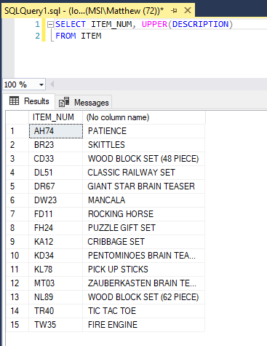
2. 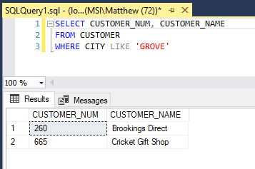
3. 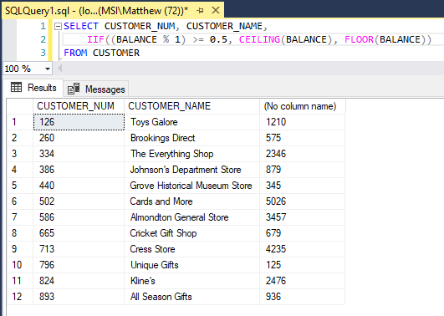
4. 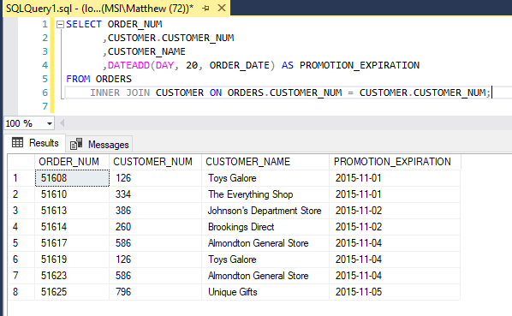
5. 1. 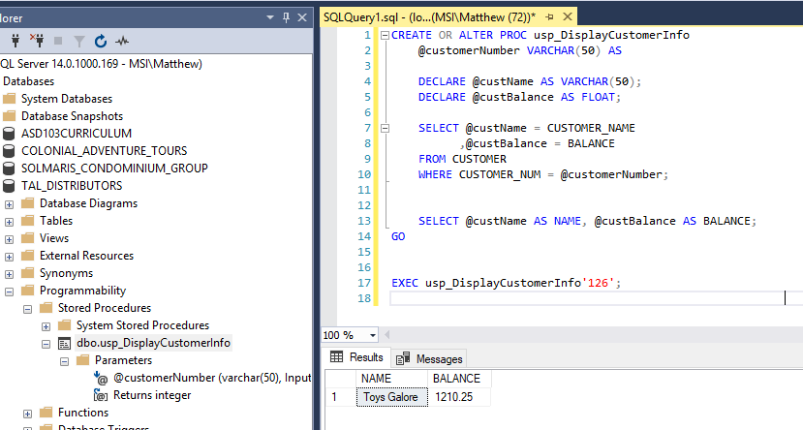
   2. 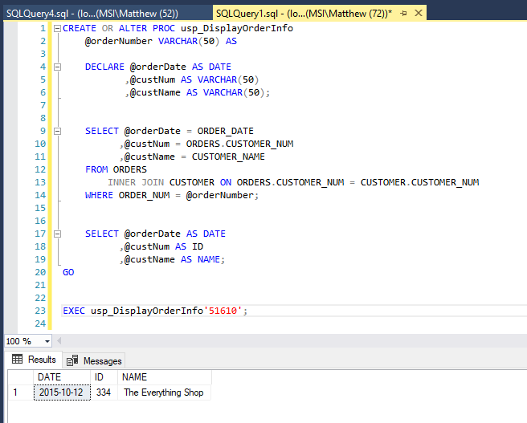
   3. 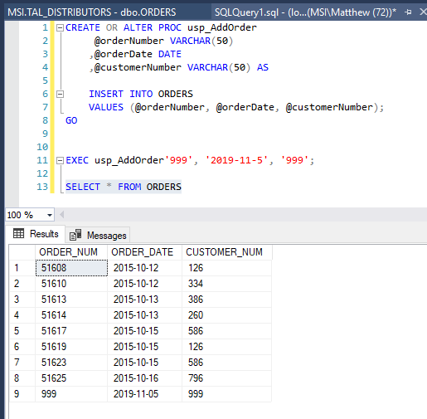
   4. 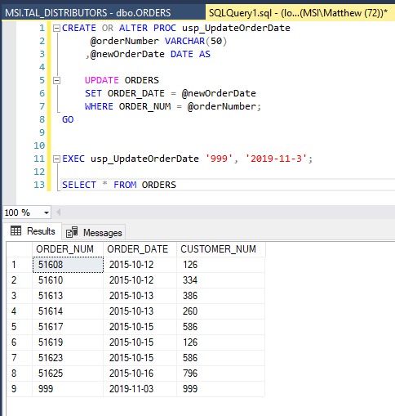
6. 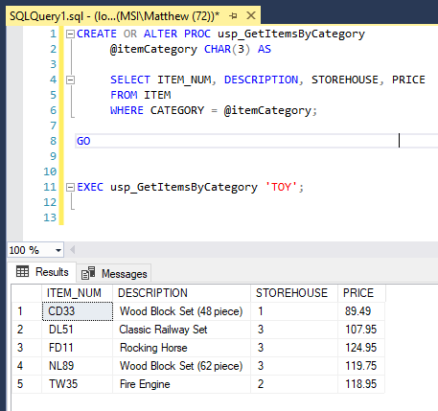
7. 1. strSQL = "DELETE FROM ORDERS WHERE ORDER_NUM = "

strSQL = strSQL & I_ORDER_NUM

strSQL = strSQL & ""

* 1. strSQL = "UPDATE FROM ORDERS SET

strSQL = strSQL & I_ORDER_DATE

strSQL = strSQL & " WHERE ORDER_NUM = "

strSQL = strSQL & I_ORDER_NUM

strSQL = strSQL & ""

* 1. strSQL = "SELECT ITEM_NUM, DESCRIPTION, STOREHOUSE, PRICE   
      FROM ITEM WHERE CATEGORY = "

strSQL = strSQL & I_CATEGORY

strSQL = strSQL & ""

1. 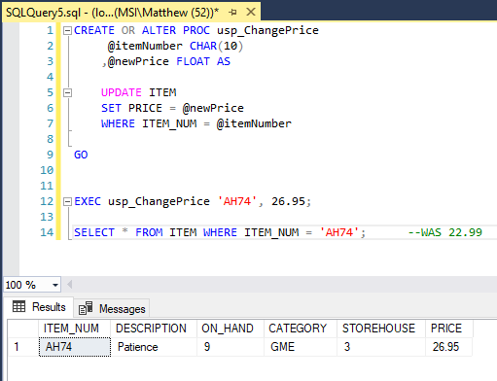
2. 1. 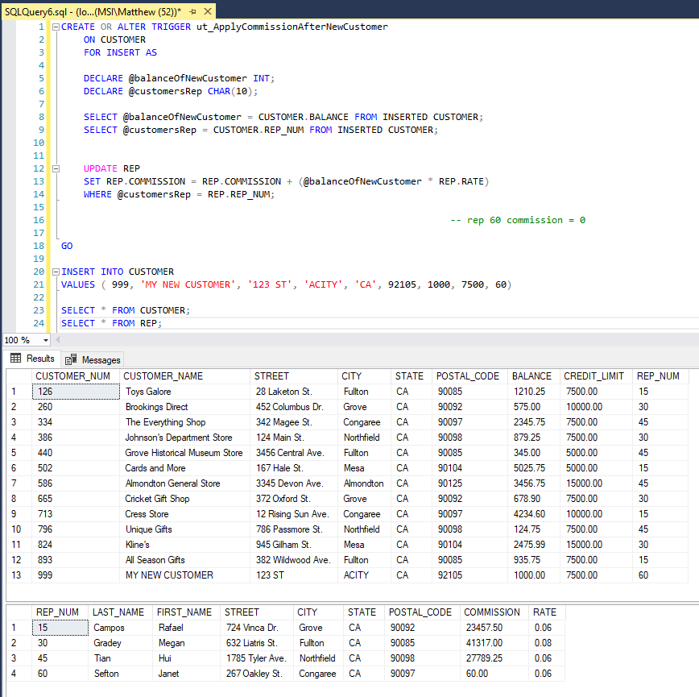
   2. 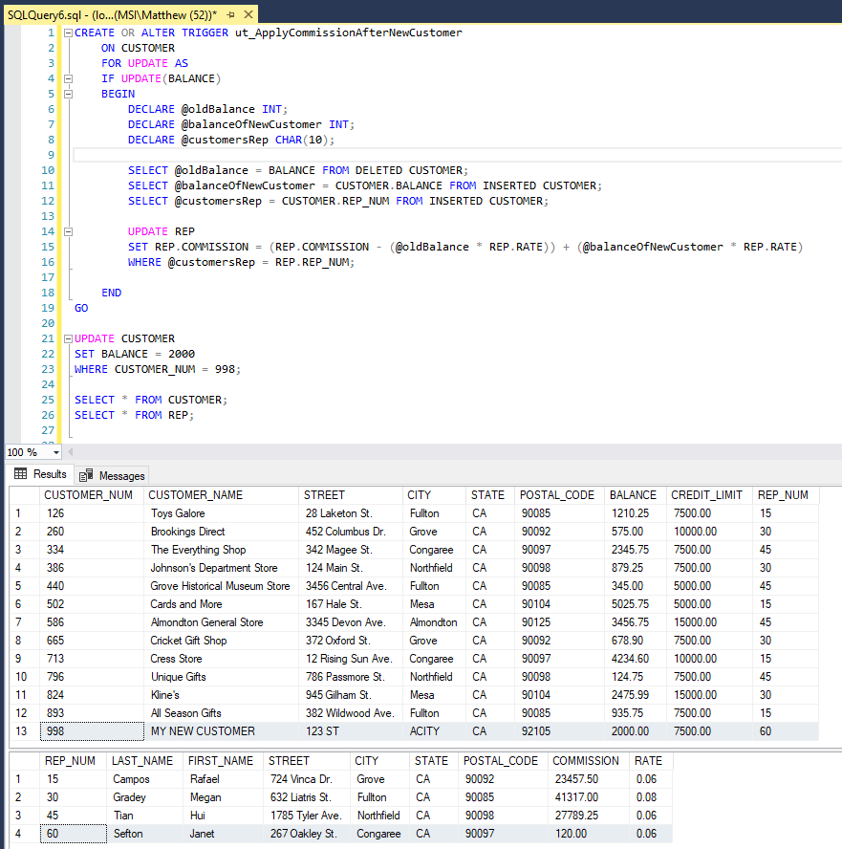
   3. 